TV SHOW API
API:
World Popular TV show API
1000 request per day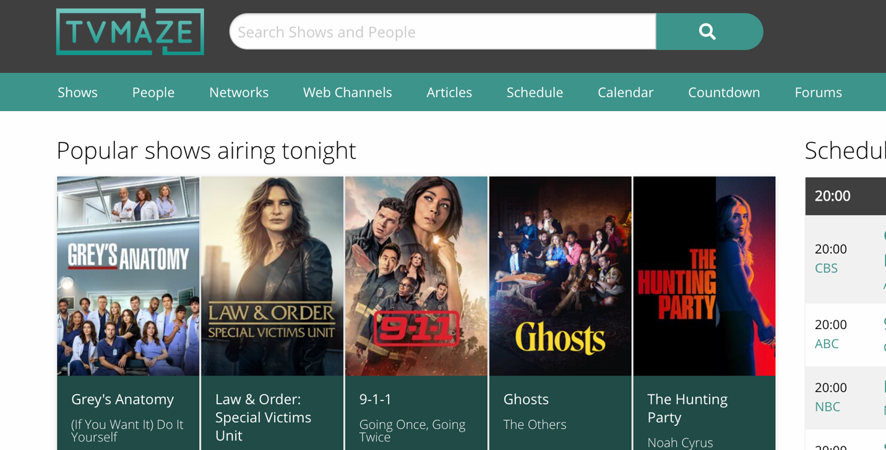

About the website
Comprehensive TV Show & Schedule Data – Offers endpoints to fetch detailed info about TV shows, including metadata, episodes, seasons, cast, crew, aliases, and images.
Search Functionality – Enables fuzzy search for shows and people by name, plus lookup by external IDs (e.g., IMDB, TVDB) to help match data accurately.
Episode Scheduling – Includes schedule endpoints to retrieve airing schedules by country and date, as well as web/streaming schedules and a full future episode list.
RESTful & JSON-Based API – Provides a free, fast, REST API that returns data in JSON and follows standards like HATEOAS and HAL for easy integration.
Embedding & Related Data Links – Allows embedding of related resources (e.g., embedding episodes when fetching show details) using query parameters.
Public & Premium Options – Includes a public API free for general use and an optional user-level API for paid/premium members with extended capabilities
API Structure
Search Shows by Name
- Endpoint: /search/shows?q=:query
- Example: https://api.tvmaze.com/search/shows?q=girls
- Returns an array of shows matching the query:
Single Show Lookup
- Endpoint: /singlesearch/shows?q=:query
- Example: https://api.tvmaze.com/singlesearch/shows?q=girls&embed=episodes
- Returns detailed info of one show with embedded episodes.
Episode Schedule by Country & Date
- Endpoint: /schedule?country=:countrycode&date=:date
- Example: https://api.tvmaze.com/schedule?country=US&date=2024-01-01
- Returns a list of episodes airing on that day in that country.
Show Lookup by External ID
- Endpoint: /lookup/shows?imdb=:id
- Example: https://api.tvmaze.com/lookup/shows?imdb=tt0944947
- Returns the show details for a given IMDb ID.
People Search
- Endpoint: /search/people?q=:query
- Example: https://api.tvmaze.com/search/people?q=lauren
- Returns a list of people (actors, directors, etc.) matching the name.

